

Scheller College of Business

APR Data Portfolio 2020 - 2021

Table of Contents

**Purpose** 1

*Student Level Data* 2

Bachelor’s Degree Level 2

**ADORS Starting Salary Data** 8

**EDEPS Supply and Demand Data** 10

*Occupational Supply Analysis of Business Management and Administration* 10

Occupational Demand Analysis of Business 16

Faculty/Staff Level Data 19

HR Profile 19

Space Data 20

Sponsored Awards 21

Budget/Encumbrance/Expenditures 23

**Purpose**

The Office of Institutional Research & Planning (IRP) has been charged with assisting in the Academic Program Review (APR) process. The purpose of the APR process is to conduct a strategic evaluation of each academic program every five years. The role of IRP is to provide a data portfolio at the onset of the review to aid in the self-study process. As such, a data portfolio is provided which includes data on students, faculty, staff, space, and finance.

# *Student Level Data*

## Bachelor’s Degree Level

Figure 1: Undergraduate Admissions by Academic Year

Figure 2: Undergraduate Admissions SAT Scores by Academic Year

Table 1: Undergraduate Enrollment Breakdown

|  |  |  |  |  |  |  |  |  |  |  |  |  |  |  |  |  |  |  |
| --- | --- | --- | --- | --- | --- | --- | --- | --- | --- | --- | --- | --- | --- | --- | --- | --- | --- | --- |
|  | **Cohort Year** | | | | | | | | | | | | | | | | | |
|  | **Fall 2015** | | | **Fall 2016** | | | | | **Fall 2017** | | | **Fall 2018** | | | | **Fall 2019** | | |
|  | **N** | **% Total** | | **N** | | **% Total** | | | **N** | **% Total** | | **N** | | **% Total** | | **N** | | **% Total** |
| **Female** | 108 | | 60.67% | | 85 | | 49.42% | 78 | | | 42.62% | | 69 | | 41.32% | | 84 | 44.21% |
| **Male** | 70 | | 39.33% | | 87 | | 50.58% | 105 | | | 57.38% | | 98 | | 58.68% | | 106 | 55.79% |
| **Total Enrollment** | 178 | |  | | 172 | |  | 183 | | |  | | 167 | |  | | 190 |  |
| **White** | 118 | | 66.29% | | 104 | | 60.47% | 104 | | | 56.83% | | 111 | | 66.47% | | 99 | 52.11% |
| **Asian** | 27 | | 15.17% | | 24 | | 13.95% | 29 | | | 15.85% | | 28 | | 16.77% | | 37 | 19.47% |
| **URM** | 19 | | 10.67% | | 29 | | 16.86% | 29 | | | 15.85% | | 26 | | 15.57% | | 49 | 25.79% |
| **Unknown** | 14 | | 7.87% | | 13 | | 7.56% | 17 | | | 9.29% | | 1 | | 0.60% | | 1 | 0.53% |
| **Multi-Racial Non-URM** | 0 | | 0.00% | | 2 | | 1.16% | 4 | | | 2.19% | | 1 | | 0.60% | | 4 | 2.11% |
| **FTE** | 155 | |  | | 152.75 | |  | 163.5 | | |  | | 150.26 | |  | | 160.08 |  |
| **Total Credit Hours** | 4,125 | |  | | 4,063 | |  | 4,334 | | |  | | 3,997 | |  | | 4,284 |  |

Table : Undergraduate Retention Rates by Cohort

|  |  |  |  |  |  |  |  |  |  |
| --- | --- | --- | --- | --- | --- | --- | --- | --- | --- |
| **Cohort** | **N** | **Years** | | | | | | | |
| **1** | **2** | **3** | **4** | **5** | **6** | **7** | **8** |
| **Fall 2011** | 169 | 97.0% | 91.1% | 89.9% | 88.8% | 88.8% | 89.3% | 89.9% | 89.9% |
| **Fall 2012** | 167 | 92.8% | 91.0% | 89.2% | 88.8% | 89.2% | 89.8% | 89.2% |  |
| **Fall 2013** | 167 | 92.8% | 94.6% | 91.0% | 91.6% | 92.2% | 92.2% |  |  |
| **Fall 2014** | 154 | 96.1% | 95.5% | 94.8% | 92.2% | 92.9% |  |  |  |
| **Fall 2015** | 174 | 95.4% | 93.1% | 93.1% | 92.5% |  |  |  |  |
| **Fall 2016** | 165 | 98.8% | 95.8% | 95.8% |  |  |  |  |  |
| **Fall 2017** | 174 | 97.7% | 95.4% |  |  |  |  |  |  |
| **Fall 2018** | 153 | 95.4% |  |  |  |  |  |  |  |
| **Fall 2019** | 177 |  |  |  |  |  |  |  |  |

Table 3: Undergraduate Graduation Rates* by Cohort

|  |  |  |  |  |  |  |
| --- | --- | --- | --- | --- | --- | --- |
| **Cohort** | **N** | **Years** | | | | |
| **4** | **5** | **6** | **7** | **8** |
| **Fall 2011** | 169 | 55.0% | 87.6% | 88.2% | 89.3% | 89.9% |
| **Fall 2012** | 167 | 61.1% | 86.2% | 88.6% | 89.2% |  |
| **Fall 2013** | 167 | 58.7% | 89.2% | 91.0% |  |  |
| **Fall 2014** | 154 | 54.5% | 92.2% |  |  |  |
| **Fall 2015** | 174 | 62.1% |  |  |  |  |
|  |  |  |  |  |  |  |

*Graduation rates reflect students who entered into the Business program but may have graduated in other programs.

Figure 3: Bachelor’s Degrees Awarded by Academic Year.

Figure 4: Master's Level Admissions by Academic Year

Table 4: Master's Level Enrollment

|  |  |  |  |  |  |  |  |  |  |  |
| --- | --- | --- | --- | --- | --- | --- | --- | --- | --- | --- |
|  | **Cohort Year** | | | | | | | | | |
|  | **Fall 2015** | | **Fall 2016** | | **Fall 2017** | | **Fall 2018** | | **Fall 2019** | |
|  | **N** | **% Total** | **N** | **% Total** | **N** | **% Total** | **N** | **% Total** | **N** | **% Total** |
| **Female** | 70 | 25.09% | 87 | 29.39% | 72 | 26.28% | 110 | 37.54% | 100 | 38.31% |
| **Male** | 209 | 74.91% | 209 | 70.61% | 202 | 73.72% | 183 | 62.46% | 161 | 61.69% |
| **Total Enrollment** | 279 |  | 296 |  | 274 |  | 293 |  | 261 |  |
| **White** | 147 | 52.69% | 167 | 56.42% | 155 | 56.57% | 161 | 54.95% | 135 | 51.72% |
| **Asian** | 65 | 23.30% | 62 | 20.95% | 55 | 20.07% | 61 | 20.82% | 65 | 24.90% |
| **Multi-Racial Non-URM** | 4 | 1.43% | 3 | 1.01% | 3 | 1.09% | 4 | 1.37% | 3 | 1.15% |
| **URM** | 63 | 22.58% | 64 | 21.62% | 61 | 22.26% | 67 | 22.87% | 57 | 21.84% |
| **Unknown** | 0 | 0.00% | 0 | 0.00% | 0 | 0.00% | 0 | 0.00% | 1 | 0.38% |
| **FTE** | 250.62 |  | 274.6 |  | 252.46 |  | 261.34 |  | 238.51 |  |
| **Total Credit Hours** | 3,418 |  | 3,822 |  | 3,539 |  | 3,786 |  | 3,432 |  |

Figure 5: Master's Degrees Awarded by Academic Year.

Figure 6: Doctoral Level Admissions by Academic Year

Table 5: Doctoral Level Enrollment Breakdown

|  |  |  |  |  |  |  |  |  |  |  |
| --- | --- | --- | --- | --- | --- | --- | --- | --- | --- | --- |
|  | **Cohort Year** | | | | | | | | | |
|  | **Fall 2015** | | **Fall 2016** | | **Fall 2017** | | **Fall 2018** | | **Fall 2019** | |
|  | **N** | **% Total** | **N** | **% Total** | **N** | **% Total** | **N** | **% Total** | **N** | **% Total** |
| **Female** | 3 | 50.00% | 5 | 55.56% | 7 | 63.64% | 4 | 44.44% | 6 | 60.00% |
| **Male** | 3 | 50.00% | 4 | 44.44% | 4 | 36.36% | 5 | 55.56% | 4 | 40.00% |
| **Total Enrollment** | 6 |  | 9 |  | 11 |  | 9 |  | 10 |  |
| **White** | 3 | 50.00% | 4 | 44.44% | 0 | 0.00% | 2 | 22.22% | 1 | 10.00% |
| **Asian** | 3 | 50.00% | 5 | 55.56% | 10 | 90.91% | 7 | 77.78% | 8 | 80.00% |
| **Multi-Racial Non-URM** | 0 | 0.00% | 0 | 0.00% | 0 | 0.00% | 0 | 0.00% | 0 | 0.00% |
| **URM** | 0 | 0.00% | 0 | 0.00% | 1 | 9.09% | 0 | 0.00% | 0 | 0.00% |
| **Unknown** | 0 | 0.00% | 0 | 0.00% | 0 | 0.00% | 0 | 0.00% | 1 | 10.00% |
| **FTE** | 6 |  | 6 |  | 11 |  | 9 |  | 10 |  |
| **Total Credit Hours** | 76 |  | 78 |  | 152 |  | 110 |  | 151 |  |

Figure 7: Doctoral Degrees Awarded by Academic Year

**ADORS Starting Salary Data**

Table 6: Bachelor's Degree Graduating Student Starting Salary

|  |  |  |  |  |  |  |  |  |  |  |  |
| --- | --- | --- | --- | --- | --- | --- | --- | --- | --- | --- | --- |
| **Career and Salary Survey (Fall 2013 - Spring 2018)** | | | | | | | | | | | |
| **Major** | **Offer Rate** | **Placement Rate** | **Number Reporting Salary** | **Population of Job-Seekers** | **Salary Offer** | | | | **Bonus** | |
| **Median** | | **High** | **Low** | **Median Bonus** | **N** |
| Business Administration | 92.7% | 79.8% | 465 | 667 | $60,000 | | $135,000 | $25,000 | $5,000 | 268 |
| Management | 92.3% | 84.0% | 168 | 212 | $55,000 | | $100,000 | $22,000 | $5,000 | 90 |
| **Overall Career and Salary Survey (Terms: Fall 2006 - Spring 2018)** | | | | | | | | | | | |
| **College** | **Offer Rate** | **Placement Rate** | **Number Reporting Salary** | **Population of Job-Seekers** | | **Median Overall Salary** | | | **Median Overall Bonus** | **N** |
| Scheller College of Business | 92.6% | 80.8% | 633 | 879 | | $60,000 | | | $5,000 | 358 |
| **Institute Career and Salary Survey (Fall 2006 - Spring 2018)** | | | | | | | | | | | |
| **Level** | **Offer Rate** | **Placement Rate** | **Number Reporting Salary** | **Population of Job-Seekers** | **Median Overall Salary** | | | | **Median Overall Bonus** | **N** |
| Bachelors | 85.7% | 73.1% | 4,451 | 7,024 | $67,500 | | | | $5,000 | 2,681 |

Table 7: Master’s Degree Graduating Student Starting Salary

|  |  |  |  |  |  |  |  |  |  |  |  |
| --- | --- | --- | --- | --- | --- | --- | --- | --- | --- | --- | --- |
| **Career and Salary Survey (Fall 2013 - Spring 2018)** | | | | | | | | | | | |
| **Major** | **Offer Rate** | **Placement Rate** | **Number Reporting Salary** | **Population of Job-Seekers** | **Salary Offer** | | | | **Bonus** | |
| **Median** | | **High** | **Low** | **Median Bonus** | **N** |
| Business Administration | 89.9% | 85.5% | 130 | 179 | $100,000 | | $213,000 | $50,000 | $20,000 | 100 |
| Global Business | 89.7% | 89.6% | 39 | 67 | $107,000 | | $230,000 | $60,000 | $30,000 | 23 |
| Management | 95.3% | 91.1% | 35 | 45 | $95,000 | | $181,500 | $53,850 | $13,500 | 16 |
| Management of Technology | 95.3% | 94.1% | 57 | 85 | $130,000 | | $275,000 | $64,000 | $25,000 | 19 |
| **Overall Career and Salary Survey (Terms: Fall 2006 - Spring 2018)** | | | | | | | | | | | |
| **College** | **Offer Rate** | **Placement Rate** | **Number Reporting Salary** | **Population of Job-Seekers** | | **Median Overall Salary** | | | **Median Overall Bonus** | **N** |
| Scheller College of Business | 91.8% | 88.9% | 262 | 377 | | $105,000 | | | $20,000 | 158 |
| **Institute Career and Salary Survey (Fall 2006 - Spring 2018)** | | | | | | | | | | | |
| **Level** | **Offer Rate** | **Placement Rate** | **Number Reporting Salary** | **Population of Job-Seekers** | **Median Overall Salary** | | | | **Median Overall Bonus** | **N** |
| Masters | 90.0% | 74.2% | 1,599 | 2,799 | $90,000 | | | | $11,000 | 831 |

Table 8: Doctoral Degree Graduating Student Starting Salary

|  |  |  |  |  |  |  |  |  |  |
| --- | --- | --- | --- | --- | --- | --- | --- | --- | --- |
| **Career and Salary Survey (Fall 2013 - Spring 2018)** | | | | | | | | | |
| **Major** | **Placement Rate** | **Number Reporting Salary** | **Population of Job-Seekers** | | **Salary Offer** | | | **Bonus** | |
| **Median** | **High** | **Low** | **Median Bonus** | **N** |
| Management | 95.0% | 17 | 20 | | $140,000 | $201,000 | $49,000 | * | * |
| **Overall Career and Salary Survey (Terms: Fall 2006 - Spring 2018)** | | | | | | | | | |
| **College** | **Placement Rate** | **Number Reporting Salary** | | **Population of Job-Seekers** | **Median Overall Salary** | | | **Median Overall Bonus** | **N** |
| **Scheller College of Business** | **95.0%** | **17** | | **20** | **$140,000** | | | **\*** | **\*** |
| **Institute Career and Salary Survey (Fall 2006 - Spring 2018)** | | | | | | | | | |
| **Level** | **Placement Rate** | **Number Reporting Salary** | **Population of Job-Seekers** | | **Median Overall Salary** | | | **Median Overall Bonus** | **N** |
| PhD | 59.6% | 526 | 1,313 | | $95,000 | | | * | * |

**EDEPS Supply and Demand Data**

*Occupational Supply Analysis of Business Management and Administration*

Table 9: Supply of Program Completers in United States by Degree Level (2017-2018)

|  |  |  |  |  |
| --- | --- | --- | --- | --- |
| **CIP Code** | **Program Title** | **Bachelor’s** | **Master’s** | **Doctorate** |
| 50.1001 | Arts, Entertainment, and Media Management, General | 486 | 301 | 0 |
| 50.1099 | Arts, Entertainment, and Media Management, Other | 130 | 229 | 0 |
| 52.0201 | Business Administration and Management, General | 140,148 | 107,449 | 2,181 |
| 52.0299 | Business Administration, Management and Operations, Other | 8,566 | 5,732 | 48 |
| 52.9999 | Business, Management, Marketing, and Related Support Services, Other | 3,572 | 1,021 | 25 |
| 52.0101 | Business/Commerce, General | 25,510 | 9,455 | 249 |
| 52.0208 | E-Commerce/Electronic Commerce | 99 | 41 | 0 |
| 52.0799 | Entrepreneurial and Small Business Operations, Other | 103 | 92 | 1 |
| 52.0701 | Entrepreneurship/Entrepreneurial Studies | 2,761 | 680 | 11 |
| 52.0702 | Franchising and Franchise Operations | 2 | 0 | 0 |
| 52.1101 | International Business/Trade/Commerce | 5,744 | 1,983 | 37 |
| 52.0206 | Non-Profit/Public/Organizational Management | 386 | 1,860 | 5 |
| 52.0213 | Organizational Leadership | 3,949 | 5,732 | 379 |
| 52.0211 | Project Management | 601 | 1,242 | 8 |
| 52.0202 | Purchasing, Procurement/Acquisitions and Contracts Management | 655 | 420 | 3 |
| 52.021 | Research and Development Management | 8 | 164 | 0 |
| 52.0212 | Retail Management | 306 | 97 | 0 |
| 52.0703 | Small Business Administration/Management | 165 | 9 | 0 |
| 52.2101 | Telecommunications Management | 0 | 24 | 0 |
|  | Total | 193,191 | 136,531 | 2,947 |

Table 10: Supply of Program Completers in Georgia by Degree Level (2017-2018)

|  |  |  |  |  |
| --- | --- | --- | --- | --- |
| **CIP Code** | **Program Title** | **Bachelor’s** | **Master’s** | **Doctorate** |
| 50.1099 | Arts, Entertainment, and Media Management, Other | 0 | 0 | 0 |
| 52.0201 | Business Administration and Management, General | 3,760 | 2,398 | 51 |
| 52.0299 | Business Administration, Management and Operations, Other | 178 | 132 | 12 |
| 52.9999 | Business, Management, Marketing, and Related Support Services, Other | 15 | 34 | 0 |
| 52.0101 | Business/Commerce, General | 969 | 423 | 6 |
| 52.0701 | Entrepreneurship/Entrepreneurial Studies | 11 | 1 | 0 |
| 52.1101 | International Business/Trade/Commerce | 93 | 20 | 0 |
| 52.0206 | Non-Profit/Public/Organizational Management | 1 | 42 | 0 |
| 52.0213 | Organizational Leadership | 165 | 50 | 0 |
| 52.0211 | Project Management | 0 | 16 | 0 |
|  | Total | 5,192 | 3,116 | 69 |

Table 11: “Business” Program Undergraduate Completers by Georgia Institutions

|  |  |  |  |  |  |  |  |  |  |  |  |  |  |  |  |
| --- | --- | --- | --- | --- | --- | --- | --- | --- | --- | --- | --- | --- | --- | --- | --- |
| **Bachelor's Degree** | **2013-14** | | | **2014-15** | | | **2015-16** | | | **2016-17** | | | **2017-18** | | |
| **Institution** | **M** | **W** | **Total** | **M** | **W** | **Total** | **M** | **W** | **Total** | **M** | **W** | **Total** | **M** | **W** | **Total** |
| Abraham Baldwin Agricultural College | 0 | 0 | 0 | 0 | 0 | 0 | 0 | 0 | 0 | 0 | 0 | 0 | 5 | 11 | 16 |
| Agnes Scott College | 0 | 0 | 0 | 0 | 3 | 3 | 0 | 9 | 9 | 0 | 15 | 15 | 0 | 17 | 17 |
| Albany State University | 20 | 31 | 51 | 12 | 44 | 56 | 21 | 52 | 73 | 12 | 43 | 55 | 11 | 20 | 31 |
| American InterContinental University-Atlanta | 11 | 18 | 29 | 13 | 30 | 43 | 10 | 26 | 36 | 34 | 94 | 128 | 50 | 111 | 161 |
| Argosy University-Atlanta | 5 | 4 | 9 | 0 | 0 | 0 | 0 | 0 | 0 | 0 | 0 | 0 | 0 | 0 | 0 |
| Atlanta Metropolitan State College | 0 | 0 | 0 | 0 | 0 | 0 | 0 | 0 | 0 | 5 | 9 | 14 | 15 | 11 | 26 |
| Augusta University | 26 | 21 | 47 | 21 | 18 | 39 | 19 | 15 | 34 | 29 | 12 | 41 | 21 | 13 | 34 |
| Bainbridge State College | 0 | 0 | 0 | 0 | 0 | 0 | 0 | 0 | 0 | 1 | 6 | 7 | 0 | 0 | 0 |
| Berry College | 6 | 7 | 13 | 12 | 9 | 21 | 12 | 7 | 19 | 23 | 11 | 34 | 13 | 1 | 14 |
| Beulah Heights University | 0 | 0 | 0 | 0 | 0 | 0 | 0 | 0 | 0 | 4 | 3 | 7 | 1 | 0 | 1 |
| Brenau University | 0 | 2 | 2 | 0 | 0 | 0 | 0 | 1 | 1 | 0 | 1 | 1 | 0 | 1 | 1 |
| Brewton-Parker College | 0 | 0 | 0 | 0 | 0 | 0 | 14 | 5 | 19 | 5 | 2 | 7 | 1 | 5 | 6 |
| Carver Bible College | 0 | 0 | 0 | 0 | 0 | 0 | 0 | 0 | 0 | 0 | 0 | 0 | 3 | 0 | 3 |
| Clark Atlanta University | 19 | 44 | 63 | 14 | 43 | 57 | 20 | 54 | 74 | 29 | 57 | 86 | 27 | 38 | 65 |
| Clayton State University | 16 | 24 | 40 | 15 | 29 | 44 | 23 | 31 | 54 | 15 | 36 | 51 | 18 | 39 | 57 |
| Columbus State University | 24 | 31 | 55 | 12 | 19 | 31 | 13 | 22 | 35 | 15 | 25 | 40 | 23 | 27 | 50 |
| Dalton State College | 18 | 13 | 31 | 23 | 16 | 39 | 35 | 15 | 50 | 24 | 15 | 39 | 24 | 20 | 44 |
| DeVry University-Georgia | 35 | 81 | 116 | 25 | 55 | 80 | 20 | 48 | 68 | 12 | 46 | 58 | 13 | 29 | 42 |
| Emmanuel College | 10 | 1 | 11 | 18 | 7 | 25 | 9 | 3 | 12 | 19 | 7 | 26 | 15 | 8 | 23 |
| Emory University | 182 | 149 | 331 | 204 | 133 | 337 | 201 | 158 | 359 | 193 | 168 | 361 | 216 | 143 | 359 |
| Fort Valley State University | 14 | 9 | 23 | 16 | 14 | 30 | 11 | 8 | 19 | 11 | 11 | 22 | 17 | 8 | 25 |
| Georgia Central University | 4 | 0 | 4 | 3 | 4 | 7 | 0 | 2 | 2 | 5 | 2 | 7 | 0 | 0 | 0 |
| Georgia College & State University | 65 | 36 | 101 | 82 | 41 | 123 | 70 | 28 | 98 | 70 | 32 | 102 | 72 | 35 | 107 |
| **Georgia Institute of Technology-Main Campus** | **211** | **181** | **392** | **224** | **183** | **407** | **217** | **180** | **397** | **184** | **186** | **370** | **188** | **160** | **348** |
| Georgia Military College | 0 | 0 | 0 | 0 | 0 | 0 | 0 | 0 | 0 | 0 | 0 | 0 | 10 | 5 | 15 |
| Georgia Southern University | 52 | 56 | 108 | 71 | 69 | 140 | 60 | 62 | 122 | 70 | 69 | 139 | 89 | 75 | 164 |
| Georgia Southwestern State University | 44 | 48 | 92 | 42 | 52 | 94 | 35 | 42 | 77 | 39 | 35 | 74 | 32 | 35 | 67 |
| Georgia State University | 133 | 140 | 273 | 114 | 152 | 266 | 145 | 112 | 257 | 107 | 119 | 226 | 106 | 119 | 225 |
| Gordon State College | 0 | 0 | 0 | 0 | 0 | 0 | 0 | 2 | 2 | 7 | 12 | 19 | 17 | 17 | 34 |
| Herzing University-Atlanta | 21 | 19 | 40 | 13 | 9 | 22 | 6 | 9 | 15 | 10 | 13 | 23 | 20 | 14 | 34 |
| Kennesaw State University | 0 | 0 | 0 | 113 | 109 | 222 | 121 | 106 | 227 | 144 | 85 | 229 | 118 | 113 | 231 |
| LaGrange College | 3 | 6 | 9 | 9 | 6 | 15 | 9 | 8 | 17 | 21 | 5 | 26 | 14 | 4 | 18 |
| Life University | 9 | 3 | 12 | 2 | 2 | 4 | 3 | 6 | 9 | 6 | 5 | 11 | 7 | 9 | 16 |
| Mercer University | 0 | 0 | 0 | 0 | 0 | 0 | 0 | 0 | 0 | 0 | 1 | 1 | 0 | 0 | 0 |
| Middle Georgia State University | 61 | 71 | 132 | 58 | 65 | 123 | 69 | 64 | 133 | 74 | 58 | 132 | 80 | 65 | 145 |
| Morehouse College | 99 | 0 | 99 | 75 | 0 | 75 | 74 | 0 | 74 | 58 | 0 | 58 | 111 | 0 | 111 |
| Oglethorpe University | 10 | 8 | 18 | 9 | 14 | 23 | 16 | 10 | 26 | 21 | 19 | 40 | 28 | 12 | 40 |
| Paine College | 6 | 4 | 10 | 4 | 3 | 7 | 5 | 4 | 9 | 11 | 5 | 16 | 6 | 3 | 9 |
| Piedmont College | 37 | 20 | 57 | 31 | 25 | 56 | 16 | 21 | 37 | 30 | 17 | 47 | 31 | 14 | 45 |
| Point University | 18 | 27 | 45 | 22 | 34 | 56 | 21 | 23 | 44 | 13 | 24 | 37 | 15 | 4 | 19 |
| Reformed University | 0 | 0 | 0 | 0 | 0 | 0 | 0 | 0 | 0 | 0 | 0 | 0 | 6 | 2 | 8 |
| Reinhardt University | 11 | 6 | 17 | 15 | 6 | 21 | 20 | 6 | 26 | 24 | 7 | 31 | 26 | 14 | 40 |
| Savannah State University | 20 | 23 | 43 | 21 | 15 | 36 | 16 | 15 | 31 | 19 | 23 | 42 | 22 | 23 | 45 |
| Shorter University | 35 | 46 | 81 | 25 | 49 | 74 | 34 | 33 | 67 | 29 | 41 | 70 | 32 | 43 | 75 |
| Shorter University-College of Adult & Professional Programs | 38 | 101 | 139 | 35 | 98 | 133 | 30 | 75 | 105 | 24 | 41 | 65 | 12 | 23 | 35 |
| South University-Savannah | 9 | 15 | 24 | 9 | 8 | 17 | 14 | 23 | 37 | 10 | 19 | 29 | 12 | 12 | 24 |
| South University–Savannah Online | 52 | 99 | 151 | 69 | 89 | 158 | 65 | 83 | 148 | 42 | 79 | 121 | 40 | 79 | 119 |
| Thomas University | 4 | 4 | 8 | 6 | 2 | 8 | 19 | 5 | 24 | 14 | 10 | 24 | 7 | 8 | 15 |
| Toccoa Falls College | 11 | 2 | 13 | 7 | 1 | 8 | 5 | 3 | 8 | 5 | 1 | 6 | 9 | 6 | 15 |
| University of Georgia | 100 | 71 | 171 | 114 | 70 | 184 | 130 | 72 | 202 | 116 | 74 | 190 | 144 | 106 | 250 |
| University of North Georgia | 78 | 42 | 120 | 78 | 54 | 132 | 94 | 66 | 160 | 111 | 83 | 194 | 108 | 75 | 183 |
| University of Phoenix-Georgia | 94 | 191 | 285 | 75 | 107 | 182 | 73 | 93 | 166 | 51 | 60 | 111 | 24 | 38 | 62 |
| University of West Georgia | 64 | 57 | 121 | 49 | 54 | 103 | 69 | 73 | 142 | 67 | 61 | 128 | 66 | 77 | 143 |
| Valdosta State University | 28 | 27 | 55 | 24 | 33 | 57 | 39 | 26 | 65 | 59 | 28 | 87 | 49 | 28 | 77 |
| Wesleyan College | 0 | 15 | 15 | 0 | 15 | 15 | 0 | 3 | 3 | 0 | 13 | 13 | 0 | 14 | 14 |
| Young Harris College | 16 | 15 | 31 | 18 | 10 | 28 | 34 | 19 | 53 | 35 | 10 | 45 | 33 | 19 | 52 |
| **Subtotal** | **1,719** | **1,768** | **3,487** | **1,802** | **1,799** | **3,601** | **1,917** | **1,728** | **3,645** | **1,907** | **1,798** | **3,705** | **2,007** | **1,753** | **3,760** |

Table 12: “Business” Program Graduate Completers by Georgia Institutions

|  |  |  |  |  |  |  |  |  |  |  |  |  |  |  |  |
| --- | --- | --- | --- | --- | --- | --- | --- | --- | --- | --- | --- | --- | --- | --- | --- |
| **Master's Degree** | **2013-14** | | | **2014-15** | | | **2015-16** | | | **2016-17** | | | **2017-18** | | |
| **Institution** | **M** | **W** | **Total** | **M** | **W** | **Total** | **M** | **W** | **Total** | **M** | **W** | **Total** | **M** | **W** | **Total** |
| Albany State University | 2 | 7 | 9 | 7 | 16 | 23 | 7 | 31 | 38 | 9 | 15 | 24 | 10 | 17 | 27 |
| American InterContinental University-Atlanta | 16 | 39 | 55 | 17 | 35 | 52 | 15 | 34 | 49 | 36 | 70 | 106 | 34 | 86 | 120 |
| Argosy University-Atlanta | 19 | 51 | 70 | 12 | 38 | 50 | 30 | 20 | 50 | 20 | 25 | 45 | 15 | 24 | 39 |
| Augusta University | 22 | 18 | 40 | 24 | 20 | 44 | 20 | 16 | 36 | 22 | 16 | 38 | 17 | 14 | 31 |
| Berry College | 6 | 8 | 14 | 3 | 4 | 7 | 2 | 9 | 11 | 5 | 5 | 10 | 8 | 3 | 11 |
| Beulah Heights University | 0 | 6 | 6 | 0 | 5 | 5 | 9 | 5 | 14 | 2 | 1 | 3 | 6 | 7 | 13 |
| Brenau University | 27 | 26 | 53 | 9 | 10 | 19 | 5 | 33 | 38 | 22 | 63 | 85 | 13 | 38 | 51 |
| Clark Atlanta University | 12 | 14 | 26 | 6 | 7 | 13 | 12 | 14 | 26 | 16 | 15 | 31 | 7 | 13 | 20 |
| Clayton State University | 22 | 38 | 60 | 34 | 29 | 63 | 48 | 33 | 81 | 40 | 37 | 77 | 47 | 36 | 83 |
| Columbus State University | 30 | 21 | 51 | 21 | 13 | 34 | 18 | 10 | 28 | 11 | 14 | 25 | 17 | 9 | 26 |
| DeVry University-Georgia | 67 | 114 | 181 | 44 | 91 | 135 | 24 | 56 | 80 | 31 | 66 | 97 | 35 | 56 | 91 |
| Emory University | 121 | 48 | 169 | 132 | 55 | 187 | 132 | 65 | 197 | 269 | 130 | 399 | 303 | 118 | 421 |
| Georgia Central University | 3 | 1 | 4 | 3 | 2 | 5 | 3 | 1 | 4 | 7 | 3 | 10 | 0 | 0 | 0 |
| Georgia Institute of Technology-Main Campus | 206 | 61 | 267 | 179 | 58 | 237 | 183 | 64 | 247 | 189 | 53 | 242 | 210 | 74 | 284 |
| Georgia Southern University | 75 | 24 | 99 | 62 | 44 | 106 | 59 | 37 | 96 | 69 | 34 | 103 | 70 | 48 | 118 |
| Georgia Southwestern State University | 11 | 17 | 28 | 11 | 14 | 25 | 4 | 7 | 11 | 6 | 9 | 15 | 8 | 21 | 29 |
| Georgia State University | 1 | 12 | 13 | 7 | 12 | 19 | 7 | 14 | 21 | 10 | 12 | 22 | 3 | 7 | 10 |
| Kennesaw State University | 0 | 0 | 0 | 100 | 70 | 170 | 97 | 57 | 154 | 100 | 68 | 168 | 106 | 93 | 199 |
| Piedmont College | 21 | 9 | 30 | 18 | 23 | 41 | 13 | 22 | 35 | 20 | 17 | 37 | 10 | 13 | 23 |
| Reinhardt University | 13 | 8 | 21 | 12 | 4 | 16 | 8 | 6 | 14 | 9 | 9 | 18 | 5 | 7 | 12 |
| Shorter University | 0 | 0 | 0 | 13 | 11 | 24 | 24 | 33 | 57 | 19 | 26 | 45 | 27 | 40 | 67 |
| Shorter University-College of Adult & Professional Programs | 34 | 28 | 62 | 21 | 29 | 50 | 20 | 48 | 68 | 16 | 31 | 47 | 15 | 21 | 36 |
| South University-Accelerated Graduate Programs | 16 | 9 | 25 | 9 | 14 | 23 | 9 | 13 | 22 | 3 | 3 | 6 | 0 | 0 | 0 |
| South University-Savannah | 11 | 19 | 30 | 3 | 5 | 8 | 6 | 12 | 18 | 9 | 12 | 21 | 7 | 14 | 21 |
| South University–Savannah Online | 51 | 50 | 101 | 20 | 41 | 61 | 16 | 35 | 51 | 20 | 29 | 49 | 14 | 17 | 31 |
| Strayer University-Georgia | 36 | 124 | 160 | 39 | 101 | 140 | 44 | 129 | 173 | 52 | 124 | 176 | 50 | 139 | 189 |
| Thomas University | 10 | 10 | 20 | 12 | 6 | 18 | 11 | 13 | 24 | 8 | 7 | 15 | 5 | 4 | 9 |
| University of Georgia | 116 | 79 | 195 | 125 | 64 | 189 | 117 | 49 | 166 | 141 | 91 | 232 | 157 | 81 | 238 |
| University of Phoenix-Georgia | 46 | 105 | 151 | 55 | 71 | 126 | 38 | 66 | 104 | 16 | 24 | 40 | 14 | 19 | 33 |
| University of West Georgia | 37 | 32 | 69 | 38 | 34 | 72 | 56 | 53 | 109 | 44 | 56 | 100 | 50 | 51 | 101 |
| Valdosta State University | 11 | 12 | 23 | 22 | 24 | 46 | 13 | 9 | 22 | 12 | 17 | 29 | 15 | 25 | 40 |
| Wesleyan College | 5 | 33 | 38 | 2 | 20 | 22 | 6 | 13 | 19 | 4 | 25 | 29 | 6 | 19 | 25 |
| **Subtotal** | **1,047** | **1,023** | **2,070** | **1,060** | **970** | **2,030** | **1,056** | **1,007** | **2,063** | **1,237** | **1,107** | **2,344** | **1,284** | **1,114** | **2,398** |
| **Doctoral Degree** | **2013-14** | | | **2014-15** | | | **2015-16** | | | **2016-17** | | | **2017-18** | | |
| **Institution** | **M** | **W** | **Total** | **M** | **W** | **Total** | **M** | **W** | **Total** | **M** | **W** | **Total** | **M** | **W** | **Total** |
| Argosy University-Atlanta | 10 | 8 | 18 | 14 | 23 | 37 | 13 | 6 | 19 | 10 | 20 | 30 | 12 | 16 | 28 |
| Georgia Institute of Technology-Main Campus | 3 | 2 | 5 | 3 | 6 | 9 | 7 | 3 | 10 | 2 | 2 | 4 | 3 | 2 | 5 |
| Georgia State University | 0 | 0 | 0 | 1 | 0 | 1 | 0 | 0 | 0 | 2 | 1 | 3 | 0 | 1 | 1 |
| Kennesaw State University | 0 | 0 | 0 | 7 | 12 | 19 | 8 | 4 | 12 | 8 | 4 | 12 | 4 | 5 | 9 |
| University of Georgia | 5 | 1 | 6 | 7 | 3 | 10 | 6 | 4 | 10 | 4 | 2 | 6 | 3 | 5 | 8 |
| **Subtotal** | **18** | **11** | **29** | **32** | **44** | **76** | **34** | **17** | **51** | **26** | **29** | **55** | **22** | **29** | **51** |

### Occupational Demand Analysis of Business

Table 13: Occupational Characteristics for Georgia and United States

|  |  |  |  |  |  |  |  |
| --- | --- | --- | --- | --- | --- | --- | --- |
|  |  | **Georgia** | | **United States** | | | |
| **SOC Code** | **Occupation** | **Growth Rate**  **2016-26** | **Median Annual Wage** | **Typical Education** | **Work Exp.** | **Typical Training** | **% Self Empl** |
| 11-3011 | Administrative Services Managers | Faster than the average | $100,620 | Bachelor's degree | Less than 5 years | None | 0.2% |
| 13-1011 | Agents and Business Managers of Artists, Performers, and Athletes | Faster than the average | $54,870 | Bachelor's degree | Less than 5 years | None | 21.2% |
| 13-1199 | Business Operations Specialists, All Other | As fast as the average | $69,380 | Bachelor's degree | None | None | 0.6% |
| 25-1011 | Business Teachers, Postsecondary | Much faster than the average | $70,630 | Doctoral or professional degree | None | None | 0.3% |
| 11-1011 | Chief Executives | Little or no change | # | Bachelor's degree | 5 years or more | None | 22.8% |
| 11-1021 | General and Operations Managers | As fast as the average | $92,450 | Bachelor's degree | 5 years or more | None | 0.6% |
| 11-3051 | Industrial Production Managers | As fast as the average | $98,260 | Bachelor's degree | 5 years or more | None | 1.4% |
| 13-1111 | Management Analysts | Faster than the average | $80,710 | Bachelor's degree | Less than 5 years | None | 17.4% |
| 11-3061 | Purchasing Managers | As fast as the average | $115,340 | Bachelor's degree | 5 years or more | None | 1.3% |
| 11-2022 | Sales Managers | As fast as the average | $128,700 | Bachelor's degree | Less than 5 years | None | 3.6% |

Table 14: Occupational Projections for Georgia

|  |  |  |  |  |  |  |  |
| --- | --- | --- | --- | --- | --- | --- | --- |
|  |  | **Employment** | | **Change 2016-26** | | **Average** | |
| **SOC Code** | **Occupation** | **Base 2016** | **Proj 2026** | **Number** | **Percent** | **Annual Openings** |
| 11-3011 | Administrative Services Managers | 8,680 | 10,040 | 1,360 | 15.6% | 870 |
| 13-1011 | Agents and Business Managers of Artists, Performers, and Athletes | 230 | 270 | 40 | 18.8% | 30 |
| 13-1199 | Business Operations Specialists, All Other | 33,670 | 38,150 | 4,480 | 13.3% | 3,650 |
| 25-1011 | Business Teachers, Postsecondary | 2,420 | 3,010 | 590 | 24.3% | 260 |
| 11-1011 | Chief Executives | 9,360 | 9,200 | -160 | -1.7% | 630 |
| 11-1021 | General and Operations Managers | 88,130 | 101,150 | 13,020 | 14.8% | 8,910 |
| 11-3051 | Industrial Production Managers | 4,870 | 5,400 | 530 | 10.9% | 410 |
| 13-1111 | Management Analysts | 24,630 | 28,750 | 4,120 | 16.7% | 2,650 |
| 11-3061 | Purchasing Managers | 1,760 | 2,030 | 270 | 15.1% | 180 |
| 11-2022 | Sales Managers | 15,240 | 17,450 | 2,210 | 14.5% | 1,580 |

Table 15: Mean Wage Trends for Georgia, 2013 – 2017

|  |  |  |  |  |  |  |  |
| --- | --- | --- | --- | --- | --- | --- | --- |
|  |  | **Mean Annual Wage** | | | | | **% Change** |
| **SOC Code** | **Occupation** | **2014** | **2015** | **2016** | **2017** | **2018** | **2014 to 2018** |
| 11-3011 | Administrative Services Managers | $92,060 | $90,290 | $91,980 | $101,930 | $116,170 | 26.2% |
| 13-1011 | Agents and Business Managers of Artists, Performers, and Athletes | $46,070 | $71,730 | $72,850 | $82,960 | $59,090 | 28.3% |
| 13-1199 | Business Operations Specialists, All Other | $70,290 | $69,790 | $70,350 | $72,390 | $75,070 | 6.8% |
| 25-1011 | Business Teachers, Postsecondary | $82,590 | $80,350 | $77,940 | $86,500 | $94,670 | 14.6% |
| 11-1011 | Chief Executives | $181,460 | $185,480 | $212,990 | $217,560 | $218,590 | 20.5% |
| 11-1021 | General and Operations Managers | $110,670 | $113,430 | $114,070 | $112,810 | $113,440 | 2.5% |
| 11-3051 | Industrial Production Managers | $93,430 | $94,770 | $98,020 | $101,340 | $104,120 | 11.4% |
| 13-1111 | Management Analysts | $92,280 | $92,790 | $94,950 | $93,740 | $93,530 | 1.4% |
| 11-3061 | Purchasing Managers | $116,490 | $113,720 | $117,800 | $121,760 | $125,290 | 7.6% |
| 11-2022 | Sales Managers | $123,850 | $123,650 | $128,140 | $132,300 | $140,820 | 13.7% |

Table 16: Median Wage Trends for Georgia, 2013 – 2017

|  |  |  |  |  |  |  |  |
| --- | --- | --- | --- | --- | --- | --- | --- |
|  |  | **Median Annual Wage** | | | | | **% Change** |
| **SOC Code** | **Occupation** | **2014** | **2015** | **2016** | **2017** | **2018** | **2014 to 2018** |
| 11-3011 | Administrative Services Managers | $81,220 | $78,960 | $81,380 | $91,440 | $100,620 | 23.9% |
| 13-1011 | Agents and Business Managers of Artists, Performers, and Athletes | $43,150 | $57,820 | $53,460 | $66,100 | $54,870 | 27.2% |
| 13-1199 | Business Operations Specialists, All Other | $65,710 | $65,700 | $65,600 | $67,850 | $69,380 | 5.6% |
| 25-1011 | Business Teachers, Postsecondary | $68,050 | $69,750 | $63,230 | $65,840 | $70,630 | 3.8% |
| 11-1011 | Chief Executives | $179,630 | $181,380 | $206,210 | # | # | N/A |
| 11-1021 | General and Operations Managers | $92,580 | $93,510 | $92,460 | $92,430 | $92,450 | -.1% |
| 11-3051 | Industrial Production Managers | $86,920 | $87,530 | $90,220 | $94,020 | $98,260 | 13.0% |
| 13-1111 | Management Analysts | $79,880 | $80,670 | $82,400 | $80,100 | $80,710 | 1.0% |
| 11-3061 | Purchasing Managers | $109,740 | $108,510 | $110,040 | $112,650 | $115,340 | 5.1% |
| 11-2022 | Sales Managers | $112,920 | $110,780 | $115,920 | $120,030 | $128,700 | 14.0% |
| **Benchmarks for Wage Trends (all occupations)** | | **2014** | **2015** | **2016** | **2017** | **2018** | **2014 to 2018** |
| Georgia Median Wage | | $32,840 | $33,430 | $34,330 | $35,040 | $35,950 | 9.5% |
| Georgia Mean Wage | | $44,670 | $45,420 | $46,540 | $47,200 | $48,280 | 8.1% |
| Georgia Mean Wage RSE | | 0.6% | 0.5% | 0.5% | 0.5% | 0.5% |  |
| National Median Wage | | $35,540 | $36,200 | $37,040 | $37,690 | $38,640 | 8.7% |
| National Mean Wage | | $47,230 | $48,320 | $49,630 | $50,620 | $51,960 | 10.0% |
| National Mean Wage RSE | | 0.1% | 0.1% | 0.1% | 0.1% | 0.1% |  |
| National Consumer Price Index C-CPI-U | | 135.5 | 135.4 | 136.7 | 139.0 | 141.9 | 4.7% |

Note: N/A indicates data not available.  
Source: U.S. Department of Labor, Bureau of Labor Statistics; Occupational Characteristics. © 2020 EDEPS - Economic Development and Employer Planning System. All rights reserved.

# Faculty/Staff Level Data

## HR Profile

Table 17: Annual Salary Profile for Business by Employee Type, Rank, and Job Title*

|  |  |  |  |  |  |  |  |  |
| --- | --- | --- | --- | --- | --- | --- | --- | --- |
|  | **FT/PT Employment** | | **Academic Rank / Inst. Title** | | **N** | | **Average Annual Salary** | |
| **Faculty** | | Full-Time | | Professor | | 29 | | $213,376 |
| Associate Professor | | 24 | | $187,199 |
| Assistant Professor | | 22 | | $182,824 |
| Lecturer | | 10 | | $126,702 |
| Senior Lecturer | | 3 | | $105,468 |
| **Postdoctoral** | |  | |  | | 12 | | $145,433 |
| **Graduate Student** | |  | | Graduate Teaching Assistant | | 14 | | $29,466 |
|  | |  | | Other | | 152 | | $19,463 |
| **Staff** | | ALL | | ALL | | 124 | | $72,756 |
| **Student Assistant** | |  | |  | | 58 | | $8,185 |
| **Overall** |  | |  | | **436** | | **$67,156** | |

Table 18: Total Annual Salary Profile for Business by Employee Type*



* Data is current as of February 6, 2020. Only employees with “Active” status were included. Source: USG Enterprise Data Warehouse – Human Resources Data Mart (HRDM)

## Space Data

Table 26: Space Utilization by Usage Type

|  |  |  |
| --- | --- | --- |
| **Use Name** | **Facility Name** | **Area (ft2)** |
| Classroom Laboratory | College of Business | 7 |
| **Total** | **7** |
| Conference Room | College of Business | 5 |
| Coda | 527 |
| **Total** | **5** |
| General Classroom | College of Business | 1 |
| **Total** | **1** |
| Learning Support Lab | College of Business | 2 |
| **Total** | **2** |
| Lounge Service | College of Business | 96 |
| **Total** | **96** |
| Office Misc. | College of Business | 57 |
|  | Coda | 4 |
|  | **Total** | **61** |
| Office Rest Room | College of Business | 81 |
| **Total** | **81** |
| Open Computing Lab | College of Business | 559 |
| **Total** | **559** |
| Open Laboratory - Dry | College of Business | 3 |
| **Total** | **3** |
| Research/Non-Classroom Lab | College of Business | 455 |
| **Total** | **455** |
| Study Room | College of Business | 8 |
| **Total** | **8** |
| Study Service | College of Business | 176 |
| **Total** | **176** |
| Wellness or Lactation Room | College of Business | 120 |
| **Total** | **120** |
|  | **Total** | **1,574** |

## Sponsored Awards

Table 27: Sponsored Awards by Sponsor Group and Fiscal Year

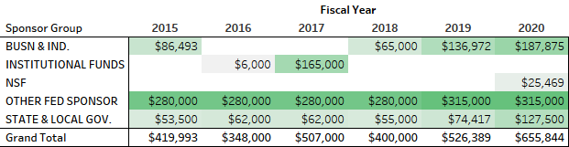

* Data retrieved from GTCrossroads Research Portal

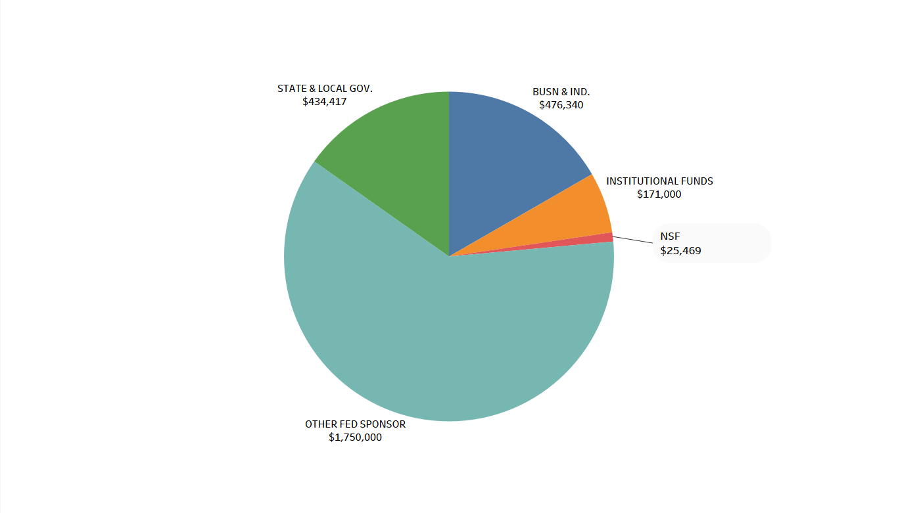

Figure 32: Total Sponsored Awards by Sponsor Group for FY 2013 to FY 2018. Data retrieved from GTCrossroads Research Portal

* Data retrieved from GTCrossroads Research Portal

Table 28: Sponsored Awards by Fiscal Year and Sponsor Group

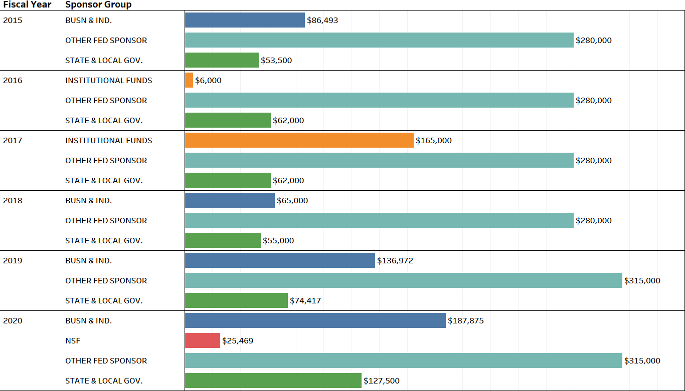

## Budget/Encumbrance/Expenditures

Table 29: Financial Profile by Transaction Description and Fiscal Year

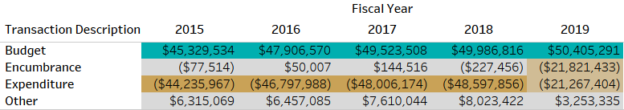

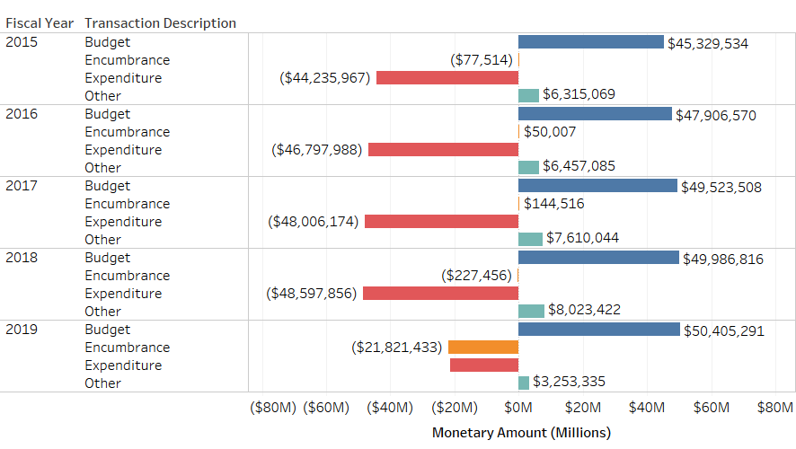

Figure 33: Financial Profile by Fiscal Year and Transaction Description